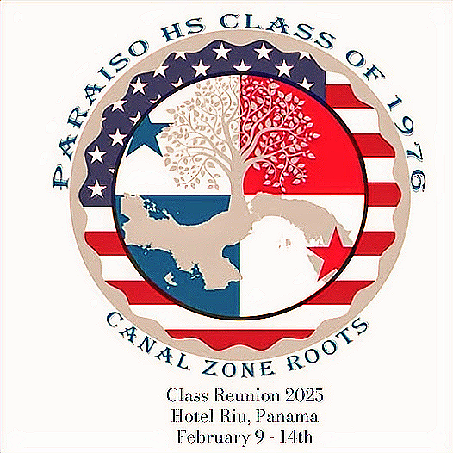
Paraiso Jr-Sr High School

Class of 1976 50th Reunion

February 9 – 14, 2026

Reunion Package Details

$150 pp
Package Sales Ended
Midnight 31-Dec-2025

***Payment methods:

-Pay with Credit Cards (on website)

or,

-Pay with Zelle to cz76phs@gmail.com followed up with an email to cz76phs@gmail.com with each attendee’s First Name, Last Name and Email address to receive their ticket electronically.

Any questions; contact anyone of us listed on the HOME Page.

T-Shirt included – Please click here to submit one T-Shirt form for each attendee purchasing a package.
Monday, February 9. 2026
Meet and greet (70’s Theme) at Torres de Alba 4:00 p.m. to 9 p.m.
Address: Calle Eusebio A Morales 55, El Cangrejo Bella Vista, Ciudad de Panamá
** Pick up package at this event between 4 – 6 p.m.

Tuesday, February 10, 2026
Bus Trip down memory lane (Paraiso, Pedro Miguel, Gamboa, Miraflores)
Depart from the Riu Plaza Hotel at 9:00 a.m. – Estimated Return Time 5 p.m.

Wednesday, February 11, 2026
Free day
Thursday, February 12, 2026
Party @ The Beach at Riu Playa Blanca – all-inclusive resort
Each person will pay for their own all-inclusive entrance fee to the resort upon arrival:
$70 for adults, $35 for children between the ages of 2 – 12 years, $52.50 retirees presenting proper documentation
Bus will depart the Riu Plaza Panama hotel at 6:00 a.m. and we will leave the resort at 6 p.m.
Friday, February 13, 2026
Sabroso Panama restaurant (Dinner/Show) – 6:00 p.m.
Self-Transport /Self-paid

Saturday, February 14, 2026
Gala Semiformal Dinner Dance – Riu Plaza Panamá Hotel
Address: Calle 50 con 53 este, Urb. Marbella – Ciudad de Panamá.
No Ticket Sales at the Door

